**Wk2D Andrew H. Rohn**

**Boolean Equations**

1. Construct the truth table for the Boolean equation: C=AB’+A’B

|  |  |  |
| --- | --- | --- |
| Inputs | | Output |
| A | B | C |
| 0 | 0 | 0 |
| 0 | 1 | 1 |
| 1 | 0 | 1 |
| 1 | 1 | 0 |

1. Draw a simple **NOT, AND, OR** circuit in sum of products (SOP) form that represents the equation above.

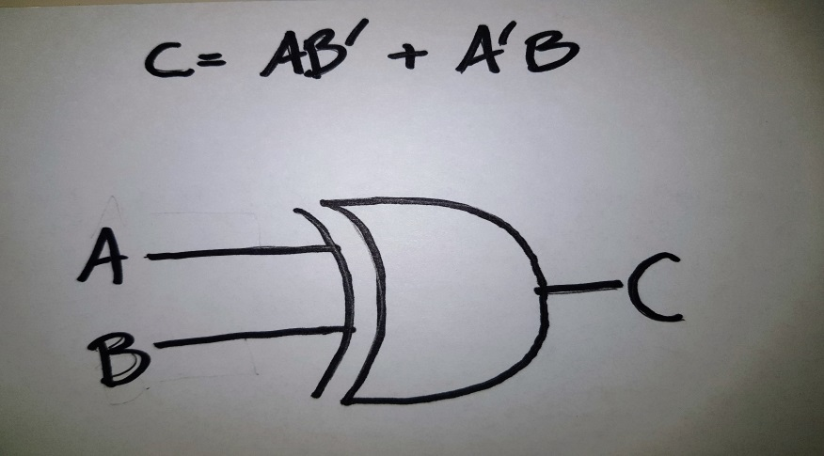

1. The truth table for a Boolean expression is shown below. Write the Boolean expression on SOP form.

|  |  |  |  |
| --- | --- | --- | --- |
| Inputs | | | Output |
| A | B | C | Sum |
| 0 | 0 | 0 | 0 |
| 0 | 0 | 1 | 1 |
| 0 | 1 | 0 | 1 |
| 0 | 1 | 1 | 0 |
| 1 | 0 | 0 | 1 |
| 1 | 0 | 1 | 0 |
| 1 | 1 | 0 | 0 |
| 1 | 1 | 1 | 1 |

Sum = A’B’C + A’BC’ + AB’C’ + ABC

1. Find the truth table that describes the following circuit:

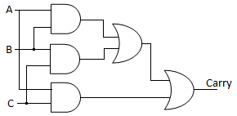

Indication:

|  |  |  |  |
| --- | --- | --- | --- |
| Inputs | | | Output |
| A | B | C | Carry |
| 0 | 0 | 0 | 0 |
| 0 | 0 | 1 | 0 |
| 0 | 1 | 0 | 0 |
| 0 | 1 | 1 | 1 |
| 1 | 0 | 0 | 0 |
| 1 | 0 | 1 | 1 |
| 1 | 1 | 0 | 1 |
| 1 | 1 | 1 | 1 |

1. Having the following circuit:

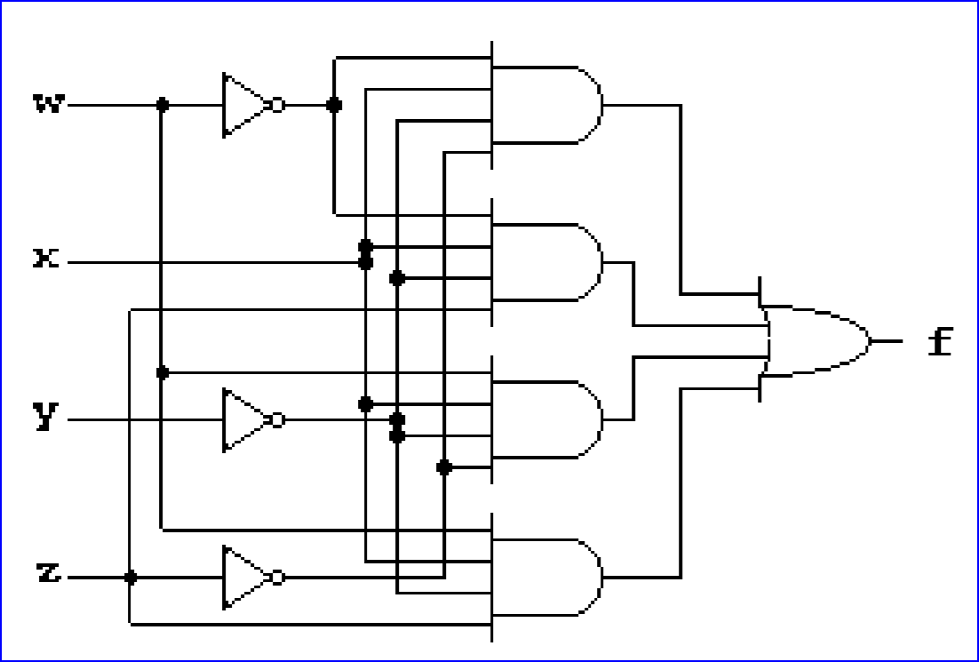

Write the Boolean expression on SOP form of the function f =

Minimize function f

Draw the minimize form of function f.

|  |  |  |  |  |
| --- | --- | --- | --- | --- |
| **w** | **x** | **y** | **z** | **f** |
| **0** | **0** | **0** | **0** | **0** |
| **0** | **0** | **0** | **1** | **0** |
| **0** | **0** | **1** | **0** | **0** |
| **0** | **0** | **1** | **1** | **0** |
| **0** | **1** | **0** | **0** | **1** |
| **0** | **1** | **0** | **1** | **1** |
| **0** | **1** | **1** | **0** | **0** |
| **0** | **1** | **1** | **1** | **0** |
| **1** | **0** | **0** | **0** | **0** |
| **1** | **0** | **0** | **1** | **0** |
| **1** | **0** | **1** | **0** | **0** |
| **1** | **0** | **1** | **1** | **0** |
| **1** | **1** | **0** | **0** | **1** |
| **1** | **1** | **0** | **1** | **1** |
| **1** | **1** | **1** | **0** | **0** |
| **1** | **1** | **1** | **1** | **0** |

**SOP Form:** **F = W’XY’Z’ + W’XY’Z + WXY’Z’ + WXY’Z**

**Minimize Form:** F = W’XY’( Z’ + Z ) + WXY’ ( Z’ + Z )

F = W’XY’ + WXY’

F = XY’( W’ + W )

**F = XY’**

**Circuit Diagram:**

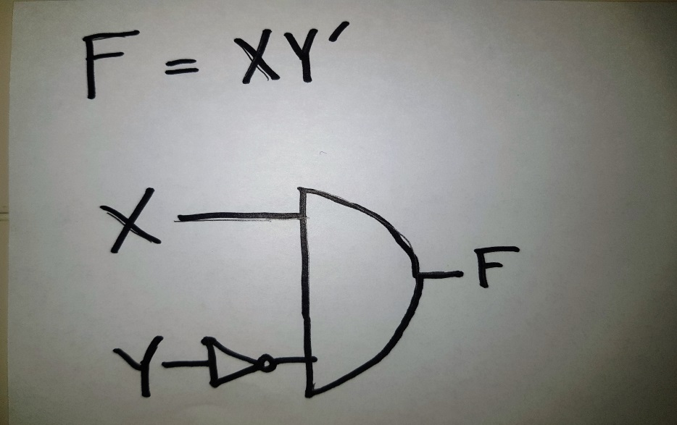

1. Nick, Jackie, William and Heather are members of the board of trustees of a big company. Decisions are made by the following criteria

A **buy** order is placed if:

1. William, Jackie and Heather vote YES, or
2. William and Jackie vote YES, or
3. Nick, Jackie and Heather vote YES, or
4. Jackie and Heather vote YES, or
5. William vote YES and Nick and Heather vote NO, or
6. Nick and William vote YES, or
7. Nick and Jackie vote NO and William and Heather vote YES

Design a simplified switch panel and logic circuits that will make the buy decision for these obviously confused stock brokers. Consider the variables N, W, J, H associated with the brokers, and D with decision.

* Establish the truth table considering YES=1 and NO=0
* Minimize using Karnaugh map
* Write the equation for D-decision in function of the votes of members
* Draw the circuits using AND, OR, NOT gates

 Could you see something special in the result?

**Truth Table:**

|  |  |  |  |  |
| --- | --- | --- | --- | --- |
| N | J | W | H | D |
| 0 | 0 | 0 | 0 | 0 |
| 0 | 0 | 0 | 1 | 0 |
| 0 | 0 | 1 | 0 | 1 |
| 0 | 0 | 1 | 1 | 1 |
| 0 | 1 | 0 | 0 | 0 |
| 0 | 1 | 0 | 1 | 1 |
| 0 | 1 | 1 | 0 | 1 |
| 0 | 1 | 1 | 1 | 1 |
| 1 | 0 | 0 | 0 | 0 |
| 1 | 0 | 0 | 1 | 0 |
| 1 | 0 | 1 | 0 | 1 |
| 1 | 0 | 1 | 1 | 1 |
| 1 | 1 | 0 | 0 | 0 |
| 1 | 1 | 0 | 1 | 1 |
| 1 | 1 | 1 | 0 | 1 |
| 1 | 1 | 1 | 1 | 1 |

**Karnaugh Map:**

|  |  |  |  |  |
| --- | --- | --- | --- | --- |
| K-map | W’H’ | W’H | WH | WH’ |
| N’J’ | 0000 | 0001 | 0011 | 0010 |
| N’J | 0100 | 0101 | 0111 | 0110 |
| NJ | 1100 | 1101 | 1111 | 1110 |
| NJ’ | 1000 | 1001 | 1011 | 1010 |

|  |  |  |  |  |
| --- | --- | --- | --- | --- |
| K-map | W’H’ | W’H | WH | WH’ |
| N’J’ | 0 | 0 | 1 | 1 |
| N’J | 0 | 1 | 1 | 1 |
| NJ | 0 | 1 | 1 | 1 |
| NJ’ | 0 | 0 | 1 | 1 |

* We can see from the K-map that D is True when W is True OR when both J and H are True.

**Function:** D = W + JH

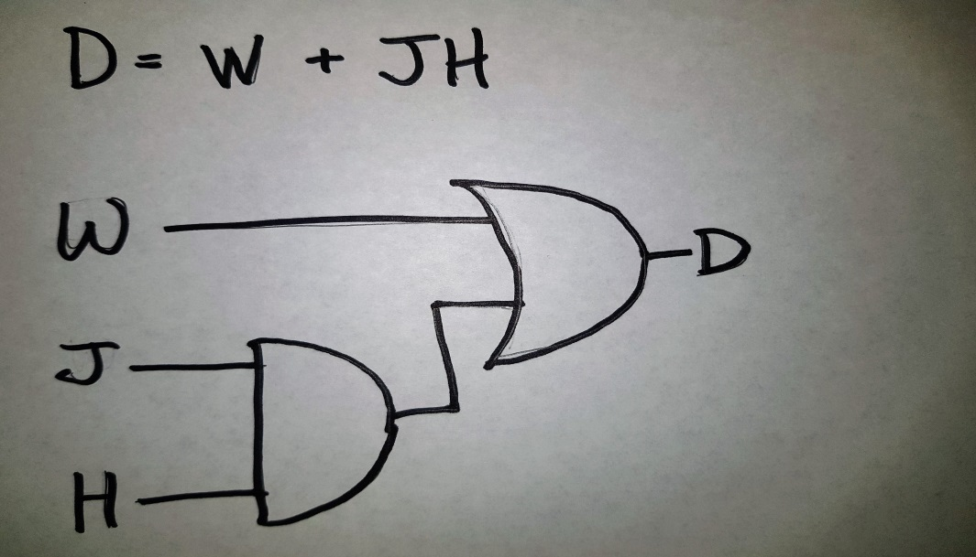

* We can see from the results that Nick’s vote isn’t a variable that affects the decision. Also, a buy order is placed every time that William votes Yes.